**Self-Care Plan**

When we are stressed out and overwhelmed it can be difficult to think and know what can help us re-center. Taking the time to develop that plan before something happens can help you and others around you know how to best assist you in a time of distress.

**Make a list of what you can do when you are feeling upset that can help you feel better**

1. 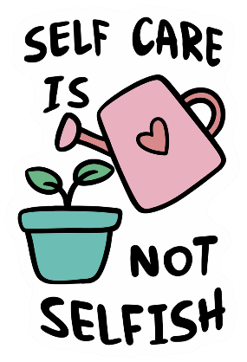What will help me relax? [Examples: breathing, muscle relaxation, music, reading, watching a movie, exercising, walking, etc.]
2. _____________________________________
3. _____________________________________
4. _____________________________________
5. What do I like to do when I am happy and/or in a good mood?
6. _____________________________________
7. _____________________________________
8. _____________________________________
9. What can I do to help me get through the next minute, hour, day? [Examples: avoiding caffeine if I feel anxious, remembering to breath, watching my thoughts, staying present, etc.]
10. _____________________________________
11. _____________________________________
12. _____________________________________
13. What else do I need that is specific to ME? ___________________________________________________________________________________________________________________________________________________________________________

**Make a list of people you can contact if you need support or a distraction.**

1. _______________________________________
2. _______________________________________
3. _______________________________________
4. 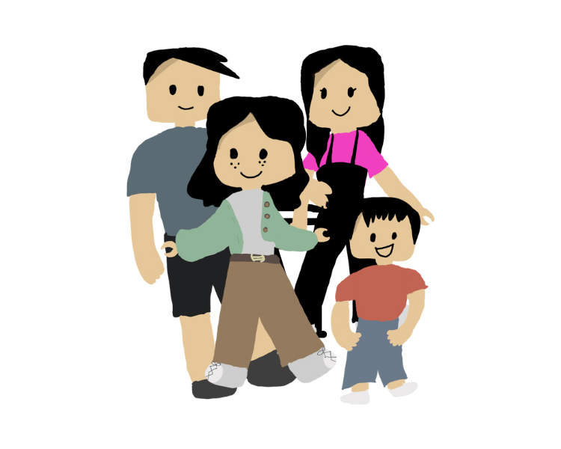_______________________________________
5. _______________________________________
6. _______________________________________
7. _______________________________________
8. _______________________________________
9. _______________________________________
10. _______________________________________
11. Divide your people into categories by asking yourself the following questions:
    1. Who can I call if I am feeling depressed or anxious?
    2. Who can I call if I feel lonely?
    3. Who will come over to be with me if I need company?
    4. Who will listen?
    5. Who will encourage me to get out of the house and do something fun?
    6. Who will remind me to follow my self-care plan?
    7. Other

**Make a list of positive things to say to yourself when you are giving yourself a hard time.**

1. __________________________________________________________________
2. __________________________________________________________________
3. __________________________________________________________________
4. __________________________________________________________________
5. __________________________________________________________________

**Make a list of who and what to avoid when you are having a difficult time.**

**______________________________________________________________________________________________________________________________________________________________________________________________________________________________________________________________________________________________________________________________________________________________**

Not everything and everyone is going to be helpful during a difficult time. It is important to know what works for you and who can best offer you the kind of support that you need. Just because you don’t reach out to certain people doesn’t make them any less important, it just means that can’t give you what you need at this exact moment in time.

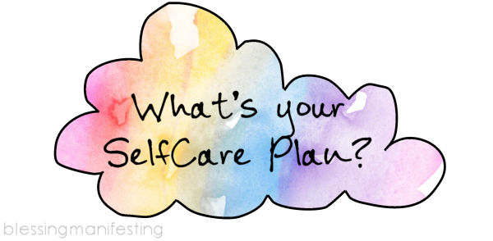**Lastly, write this plan on your phone or a notecard and always carry it with you and be sure to USE IT. Also make any updates or changes as you learn things that work or don’t work for you anymore. Most importantly…remember to take care of yourself because you matter.**